**Team #5 - Dream Estate**

**ITSC 3155 Final Project Report**

**Prepared by: Krish Pandya, Abdullahi Ahmed, and Mark Feng**

**Date: 12/8/21**

**1****Introduction**

1.1 Product Vision 3

1.3 Project Scope and Objectives 4

1.4 Ethical concerns 4

**2 Project Resources** **4**

2.1 Group Members 4

2.2 Data 5

2.3 Hardware and Software Resources 5

2.4 Special Resources 5

**3 Plan** **5**

3.1 Timeline Chart 5

3.2 Task / Milestone Descriptions 6

3.3 2.3 Resource Table 6

**4 System Design** **7**

4.1 Use Case Diagram 7

4.2 DFD diagram 7

4.3 User Stories 8

4.4 Feature List 8

4.5 Storyboard 8

**5 User Tests** **9**

5.1 Test procedure 10

5.2 User Test and Results 10

5.3 Conclusion 10

**6 Lessons Learned** **10**

**7 Future work** **10**

**8 Appendices** **11**

8.1 Sketches 11

8.2 Software Repository 11

1 Introduction

The idea of this project is to create an entirely new real estate, home buying platform for the retail market. Current competitors offer such platforms but lack a multitude of variables that are highly important when purchasing a new home such as crime rate, schools in a given location among others. In addition to this lack of key factors, these competitors such as Zillow also tend to overwhelm customers with an expansive array of information rather than an efficient and easy to use user interface and user experience.

Dream Estate aims to change this by reimagining how buying a home can look through a more modern real estate platform approach. This platform provides all the factors you need to make an informed decision when buying a home with none of the hassle and overwhelming experience on Zillow.

## 1.1 Product Vision

Dream Estate is a new real estate, home buying platform for the person pursuing the right home. Dream Estate is a real estate website that allows the customer to access information such as prices, crime rate, education quality and general weather of North Carolina. Adding a multitude of features never used before with Zillow, Dream Estate further offers a simpler user experience.

1.2 Customer Description

Our customer is an individual who is looking to buy a home while considering important factors such as price, general weather, crime rate and education quality in North Carolina. Our product is geared to simplifying the survey process for purchasing a house while considering the above criteria.

## 1.3 Project Scope and Objectives

Adds features such as:

* Home prices
* Average weather in location
* Coronavirus in North Carolina counties
* Average crime rate state by state

## 1.4 Ethical concerns

Considering that the data being used within the scope of the project is all publicly available, there are no particular ethical concerns at this time.

# 2 Project Resources

See 2.2 Data section.

## 2.1 Group Members

1. Abdullahi Ahmed
2. Krish Pandya
3. Mark Feng
4. Steven Volovar

## 2.2 Data

The data will be collected from a set of verified and publicly available real estate pricing sets. The most heavily utilized dataset will be the Zillow dataset that the company makes available to the public through its site. This set of data is available here: [Zillow](https://www.zillow.com/nc/home-values/). A multitude of other sources will also be used to compile together a holistic real estate platform so customers can effectively and efficiently make home buying decisions. This data will come from [USA Facts](https://usafacts.org/data/topics/security-safety/crime-and-justice/crime-and-police/violent-crimes/), [NOAA](https://www.ncdc.noaa.gov/cag/county/mapping/31/tavg/202111/1/value), and [USA Facts COVID](https://usafacts.org/visualizations/coronavirus-covid-19-spread-map/state/north-carolina).

## 2.3 Hardware and Software Resources

In terms of hardware for the scope of this project, nothing outside of the laptops already used by the personnel in this project is needed. High performance computing and subsequent specialized hardware is not needed. In terms of software, Flask is the primary framework used, with Python and HTML as the languages.

## 2.4 Special Resources

None.

# 3 Plan

This section contains a list of tasks and deliverables associated with the project, a Gantt chart

depicting task durations, dependencies and completion dates, and a summary of resource

requirements and assignments for each task.

## **3.1** Timeline Chart

Gantt Chart (with key milestones pictured here).

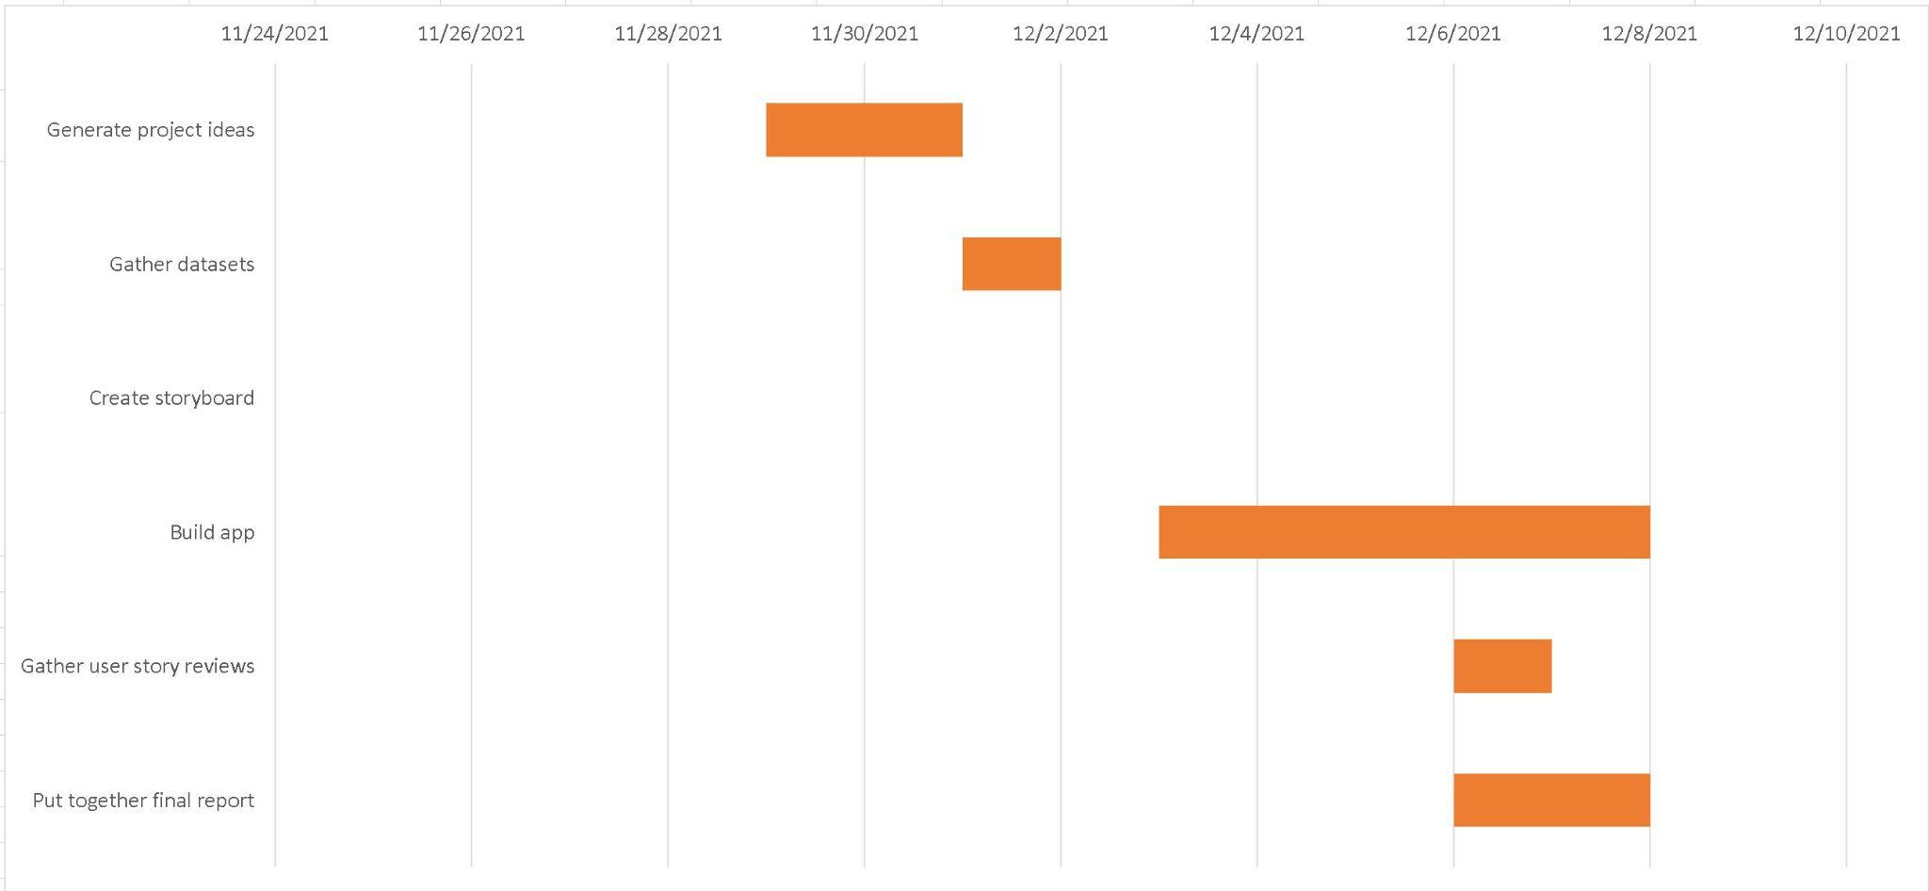

## **3.2** Task / Milestone Descriptions

Milestone 1 - Generate project ideas / Start the brainstorming process to identify a reasonable and unique project to complete within the scope provided

Milestone 2 - Gather datasets / Utilize resources and search for four unique datasets (as specified within the scope of the project) to be used within the MVP

Milestone 3 - Create storyboard / Map out the vision of what the MVP should look like

Milestone 4 - Build app / Create the MVP through coding principles and software engineering methods

Milestone 5 - Gather user story reviews / Generate user stories and ask paired team for reviews on how the MVP can be navigated to reach the target user’s intended interest

Milestone 6 - Put together final report / Fill out documentation and final updates on the project

## 3.3 2.3 Resource Table

| **Task** | **People** |
| --- | --- |
| **Milestone 1, 2, 6** | **Krish Pandya** |
| **Milestone 4, 5** | **Abdullahi Ahmed** |
| **Milestone 3** | **Mark Feng** |

# 4 System Design

## 4.1 Use Case Diagram

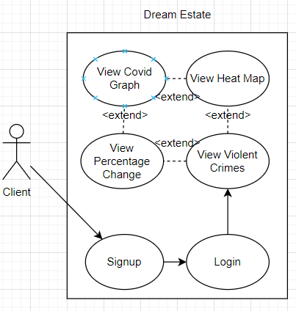

## 4.2 DFD diagram

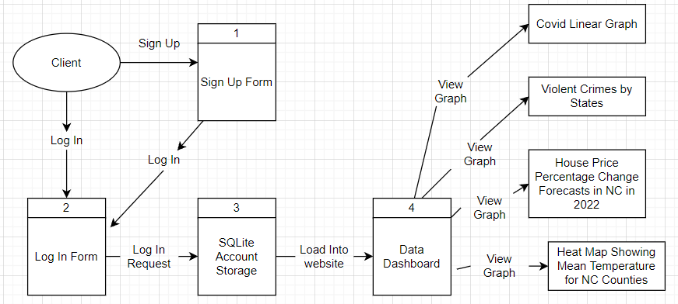

## 4.3 User Stories

* As a current Texan who is considering moving to North Carolina and wants to compare violent crime rates across states, I would like to know how North Carolina fares on a national scale.
* As an immigrant looking to be resettled in the US in December 2021, from Namibia, I would like to access a heat map of North Carolina to determine what County would be best for my smooth adjustment to the North Carolina climate.
* As a graduate from UCLA with job offers from a few counties in North Carolina, I would like to determine what the home price change forecast is like as I am looking to buy a house.
* As a father who is interested in touring potential counties for relocation, I would like to know the covid cases in NC on a county to county basis so I may relocate to a relatively safe county.

## 4.4 Feature List

**Graphs:**

* Covid-19 Linear Graph
* Violent Crimes by State
* House Price Percentage Change Forecasts in North Carolina in 2022
* Heat Map showing Mean Temperature in North Carolina

## 4.5 Storyboard

# 

# 

# 5 User Tests

## 5.1 Test procedure

The testing procedure was simple. Team 5 matched with their partner team over Google Meet to gather first hand information. The partner team was assigned a user story and was asked whether given the situation presented, they could effectively navigate Team 5’s MVP to find the information needed for that user. This simple test proved whether the MVP was easily accessible and could be used by the end customers.

## 5.2 User Test and Results

The results were as expected, the MVP was easy to use and feedback was overwhelmingly positive. Given the user stories, the target team could easily navigate through the product and they easily understood what the end goal of the product and target customers was.

## 5.3 Conclusion

The partner team feedback was positive and encouraging. These results mean that given a target audience is using the product, the customer can efficiently navigate through the MVP and find their desired query.

# 6 Lessons Learned

Team 5 as a whole learned a wide variety of lessons from the completion of this project. The major lesson being the importance of dividing up work. This ability to split work amongst team members not only saves time and increases productivity, but in fact also plays to the strengths of each team member. Through facilitated discussion, we were able to determine the strengths of each team member and subsequently proceeded to give each member what they were confident with to increase time of completion rather than learning time. Essentially spending more time doing and less time learning. This ability also reflects how a real world work environment operates in the software engineering sector.

Another lesson learned was time management. Through a pre-planned breakdown of key milestones to reach during the course of the project, team members never felt rushed or pressed for time. This is also a key skill to have learned for a professional SWE environment.

# 7 Future work

Looking towards the future, Team 5 still believes that many features could be added to Dream Estate, which significantly would improve the overall user experience. These features could not be added to the MVP simply due to the limited scope of the project.

A particular feature example is the ability for the user to go through a series of questions as a checklist experience. These questions would ask the user the type of weather they prefer in their ideal location, or if they value quality of education near their housing (important if they have children).

Another feature is the ability to display houses like certain competitors and then having the option to filter through these matches as a user.

The final feature that is essential in a modern world is “predictive matching.” Predictive matching utilizes artificial intelligence to derive housing options based on preset user answers. It takes the question checklist feature and expands upon it. Based on previous answers given, it will then create a user profile and optimize over time to provide better housing matches for the user in similar criteria.

**As an overall note; Team 5 is satisfied with the product created (the MVP of Dream Estate). They recognize that great companies like AirBnB and Zillow also went through basic iterations of their product once a basic MVP was launched and that the MVP launched by these companies was not an exceptional product by any means - simply sufficient for the time, but gradually improved over time with scale and growth.**

# 8 Appendices

## 8.1 Sketches

## 8.2 Software Repository

GitHub repo: <https://github.com/abhas955/SoftwareEngFinalProject>

8.3 WBS tool

Excel.

This section contains any additional information that you would like to include in the project proposal and plan.